

Crossroads   
Release Notes

Release 6.29.00

Revision 1.9

09/11/2014

**Code Release Checklist**

Product/Application/Service: Crossroads

Release Notes: __X__

Build Kit Identification: _Crossroads6.29.00 _________________

Directory/Table changes required: None

Scheduled Release Date: 09/21/2014

OS release is being tested with: Linux

OS patch version level _RHEL5.6 2.6.18-238.5.1.el5

Third party software version:

System Test: Development:

Iplanet Web Server 7 SP6 Iplanet Web Server 7 SP6

ODSEE 11.1.1.7 ODSEE 11.1.1.7

Proxy Server: OHS 11.1.1.7 Proxy Server: OHS 11.1.1.5

Apache 2.2.15 Apache 2.2.15

Java JDK 1.6.0_24 Java JDK 1.6.0_24

Development Resource On Call:

Name: Sarath Mani (Primary)

Phone: 813-484-0016 (Mobile)

813-333-5822 (Home)

Name: Gaurav Sharma (Secondary)

Phone: 813-482-1427 (Mobile)

813-774-4552 (Home)

Name: Jim Paauw (Secondary)

Phone: 813-493-2467 (Mobile)

727-527-3195 (Home)

Tested

Browser levels _____ IE 8.0 _____

Testing Completed By: _Centralized Test –

Comments: Please list any dependencies that this release may have in relation to other application(s) releases.

**Revision History**

|  |  |  |
| --- | --- | --- |
| **Revision Number** | **Date** | **Reason** |
| 1.0 | 07/24/2014 | Initial Release |
| 1.1 | 8/13/2014 | Corrected LDIF file name |
| 1.2 | 08/15/2014 | Added A2P |
| 1.3 | 08/20/2014 | Updated with ICSMS Metcalf and system test steps. |
| 1.4 | 08/21/2014 | Updates for A2P |
| 1.5 | 08/21/2014 | Updated the system test section |
| 1.6 | 08/28/2014 | Updated with separate section for Systest, UAT & Parallel environments |
| 1.7 | 09/03/2014 | Updated. |
| 1.8 | 09/09/2014 | Updated with A2P Analyzer release number |
| 1.9 | 09/11/2014 | Removed the grant Backout sql step |

**Table of Contents**

1 Release Overview 5

1.1 Overview 5

1.1 Data Security [PR_4068] 5

1.2 ICSMS Metcalf - INC000000087743 5

1.3 Customer Impact 6

1.4 Processor Impact 6

1.5 Data Impact 6

1.6 Interfacing or Related System Impact 6

1.7 Network Impact 6

1.8 Data Center Impact 6

2 Changes 7

2.1 Tables/Files 7

2.2 Job Processing 7

3 Implementation Tasks 7

3.1 Release Procedures 7

3.1.1 Pre-Release Requirements 7

3.1.2 Crossroads – Director 7

3.1.3 Backout Procedure 15

4 Steps for 7.xx System Test, UAT & Parallel Environments 15

4.1 Backout Procedure 17

4.2 Monitoring/Verification Procedures 18

4.2.1 Data Security 18

4.2.2 A2P 20

For Non Syniverse Company 20

For Syniverse Company 20

4.2.3 ICSMS Metcalf INC87743 21

5 Test Procedures 22

# Release Overview

## Overview

This release includes the following:

## Data Security [PR_4068]

**The Data Security functional design document explains all the functionalities related to Data Security items.**

**Here is the Design document link:** <http://central.syniverse.com/sites/TECH/arch/Crossroads/_layouts/WordViewer.aspx?id=/sites/TECH/arch/Crossroads/Release%20Documentation/Crossroads%20Design%20for%20Data%20Security%20UI.docx&Source=http%3A%2F%2Fcentral%2Esyniverse%2Ecom%2Fsites%2FTECH%2Farch%2FCrossroads%2FRelease%2520Documentation%2FForms%2FCustom%2520Group%2520View%2Easpx%3FGroupString%3D%253B%25236%252E29%252E00%253B%2523Design%253B%2523%26IsGroupRender%3DTRUE&DefaultItemOpen=1&DefaultItemOpen=1>

**Note: Please check the Section 4.3 MONITORING/VERIFICATION PROCEDURES for more description and screen-shots.**

## ICSMS Metcalf - INC000000087743

**The ICSMS Metcalf - INC000000087743 functional design document explains all the functionalities related to ICSMS Metcalf - INC000000087743 items.**

**Here is the Design document link:**

<http://central.syniverse.com/sites/TECH/arch/Crossroads/_layouts/WordViewer.aspx?id=/sites/TECH/arch/Crossroads/Release%20Documentation/Crossroads%20Design%20ICSMS_Metcalf_INC87743.docx&Source=http%3A%2F%2Fcentral%2Esyniverse%2Ecom%2Fsites%2FTECH%2Farch%2FCrossroads%2FRelease%2520Documentation%2FForms%2FCustom%2520Group%2520View%2Easpx%3FGroupString%3D%253B%25236%252E29%252E00%253B%2523Design%253B%2523%26IsGroupRender%3DTRUE&DefaultItemOpen=1&DefaultItemOpen=1>

**Note: Please check the Section 4.3 MONITORING/VERIFICATION PROCEDURES for more description and screen-shots.**

Risks

## Customer Impact

None

## Processor Impact

Negligible

## Data Impact

None

## Interfacing or Related System Impact

Data Security 1.00.00

A2P Analyzer ( enmob_msg 1.01.00 )

ICSMS Metcalf M182

## Network Impact

None

## Data Center Impact

No additional impact.

# Changes

## Tables/Files

No changes.

## Job Processing

No changes.

# Implementation Tasks

This section describes in detail the steps that need to be performed to install this software release. Each step should be completed and verified before proceeding to the next step. Any queries should be directed to the development team.

## Release Procedures

#### Pre-Release Requirements

##### DNS Requests

##### Request the following DNS entries as CNAMEs to crossroads.syniverse.com:

* **datasecurity.syniverse.com [PROD]**
* **anza2p.syniverse.com [PROD]**

##### Functional User ID

##### A functional user ID will need to be created for the Data Security UI app, which will be used to access the Web Service and the OID authenticator.

##### A functional user ID will need to be created for the A2P app, which will be used to access the Web Service and the OID authenticator.

#### Crossroads – Director

|  |  |
| --- | --- |
|  | **Software Install** |
|  | **Proxy Configurations** |
|  |  |
| Step 1 | **Create datasecurity.sp file if it doesn’t exists:**  **<VirtualHost *:7777>**  **ServerName datasecurity.syniverse.com**  **MaxKeepAliveRequests 0**  **KeepAliveTimeout 70**  **RequestHeader set WL-Proxy-SSL true**  **ProxyPreserveHost On**  **AddCertHeader HTTPS**  **<Location />**  **order allow,deny**  **deny from all**  **</Location>**  **<Location /datasec-ViewController-context-root>**  **order deny,allow**  **allow from all**  **SetHandler weblogic-handler**  **KeepAliveSecs 70**  **WLProxySSL ON**  **WLProxySSLPassThrough ON**  **WebLogicCluster [Please check with Data Security ops]**  **WLLogFile ${ORACLE_INSTANCE}/diagnostics/logs/${COMPONENT_TYPE}/${COMPONENT_NAME}/weblogic-datasecurity.log**  **FileCaching OFF**  **Debug ALL**  **DebugConfigInfo On**  **</Location>**  **Create anza2p.sp file if it doesn’t exists:**  **<VirtualHost *:7777>**  **SetHandler ccv**  **ServerName anza2p.syniverse.com**  **<Location />**  **order allow,deny**  **deny from all**  **</Location>**  **<Location ~ "/analytics/">**  **order deny,allow**  **allow from all**  **SetHandler weblogic-handler**  **RequestHeader set IS_SSL ssl**  **RequestHeader set WL-Proxy-SSL true**  **WebLogicCluster [Please check with ACCWEB ops]**  **</Location>**  **</VirtualHost>**  **Note: If datasecurity is NOT on clustered mode then use WebLogicHost & WebLogicPort instead of WebLogicCluster parameters.**  **Note: If anza2p is NOT on clustered mode then use WebLogicHost & WebLogicPort instead of WebLogicCluster parameters.** |
| Step 2 | **Restart Webtier servers in active environment**  (chixroads0103 & chixroads0104)    A) On chixroads0103 do the following:    1) Stop OHS instance    ohsbin  ./opmnctl stopall   2) Review the ohslog    (Note: may see complaints about threads not stopping)  ohslogs1  tail -f ohs1.log  ctrl-c    ohslogs2  tail -f ohs2.log  ctrl-c    3) Look for any httpd.worker processes and opmn processes (kill any processes that are still running)    ps -ef | egrep 'httpd.worker|opmn' | grep '^xroads'    4) get the sum for httpd.conf and any other vhost files, to compare with chixroads0104 after copy  ohsconfig1  cd vhosts  <create **datasecurity**.sp file>  <create **anza2p**.sp file>  Copy these.sp files if they are already created instead of creating them.  sum datasecurity.sp  sum anza2p.sp  ohsconfig2  cd vhosts  <create **datasecurity**.sp file>  <create **anza2p**.sp file>  Copy these.sp files if they are already created instead of creating them.  sum datasecurity.sp  sum anza2p.sp     ohsbin  ./opmnctl startall  opmn-stat    5) Verify there aren't any errors on ohs*.log files    ohslogs1  tail -f ohs1.log  ctrl-c    ohslogs2  tail -f ohs2.log  ctrl-c    6) Verify that you see activity in the access logs before stopping other proxy server    ohslogs1  tail -f access_log    ohslogs2  tail -f access_log    7) Execute ohsconfig1 to put you in the proper directory    ohsconfig1  cd vhosts   8) Copy the httpd.conf **(OR new .sp file)** file from chixroads0103 to chixroads0104    scp **datasecurity.sp** [xroads@chixroads0104:/thirdparty/Oracle/Middleware/Oracle_WT1/instances/instance1/config/OHS/ohs1/vhosts/**datasecurity**.sp](mailto:xroads@chixroads0104:/thirdparty/Oracle/Middleware/Oracle_WT1/instances/instance1/config/OHS/ohs1/vhosts/cspasia.sp)    scp **anza2p.sp** [xroads@chixroads0104:/thirdparty/Oracle/Middleware/Oracle_WT1/instances/instance1/config/OHS/ohs1/vhosts/**anza2p**.sp](mailto:xroads@chixroads0104:/thirdparty/Oracle/Middleware/Oracle_WT1/instances/instance1/config/OHS/ohs1/vhosts/anza2p.sp)    ohsconfig2  cd vhosts    scp **datasecurity.sp** [xroads@chixroads0104:/thirdparty/Oracle/Middleware/Oracle_WT1/instances/instance1/config/OHS/ohs2/vhosts/**datasecurity**.sp](mailto:xroads@chixroads0104:/thirdparty/Oracle/Middleware/Oracle_WT1/instances/instance1/config/OHS/ohs2/vhosts/cspasia.sp)  scp **anza2p.sp** [xroads@chixroads0104:/thirdparty/Oracle/Middleware/Oracle_WT1/instances/instance1/config/OHS/ohs2/vhosts/**anza2p**.sp](mailto:xroads@chixroads0104:/thirdparty/Oracle/Middleware/Oracle_WT1/instances/instance1/config/OHS/ohs2/vhosts/anza2p.sp)    B) Go to server chixroads0104 and do the following:    1) Stop OHS instances    ohsbin  ./opmnctl stopall    2) Review the ohslog    (Note: may see complaints about threads not stopping)  ohslogs1  tail -f ohs1.log  ctrl-c    ohslogs2  tail -f ohs2.log  ctrl-c    3) Look for any httpd.worker processes and opmn processes (kill any processes that are still running)    ps -ef | egrep 'httpd.worker|opmn' | grep '^xroads'    4) compare to chixroads0103 (see prevous section for comparison)  ohsconfig1  cd vhosts  **sum datasecurity.sp**  **sum anza2p.sp**  ohsconfig2  cd vhosts  **sum datasecurity.sp**  **sum anza2p.sp**  ohsbin  ./opmnctl startall    opmn-stat  opmn-stat2  5) Verify there aren't any errors on ohs1.log    ohslogs1  tail -f ohs1.log  ctrl-c    ohslogs2  tail -f ohs2.log  ctrl-c  6) Verify that you see activity in the access log    ohslogs1  tail -f access_log    ohslogs2  tail -f access_log |
| Step 3 | Transfer the tar file from hwcmb01:  /ccm_builds/crossroads/release_output6.29.00/2014MMDD/*CrossRoads6.29.00.2014MMDD.tar*  to the application tier servers.  The exact file name will be provided in the signoff email.  **Production steps:**  **As your own ID:**  # cd /tmp  # scp hwcmb01:/ccm_builds/crossroads/release_output6.29.00/2014MMDD/CrossRoads6.29.00.2014MMDD.tar .  # ssh hwcmb01 cksum /ccm_builds/crossroads/release_output6.29.00/2014MMDD/CrossRoads6.29.00.2014MMDD.tar  # chmod 777 CrossRoads6.29.00.2014MMDD.tar  **sudo to xroads**  # sudo su - xroads  **Move the release tar to /share1/xroads/releases:**  # cd /share1/xroads/releases  # mv /tmp/CrossRoads6.29.00.2014MMDD.tar .  # cksum CrossRoads6.29.00.2014MMDD.tar  **Ensure the cksum's match.** |
| Step 4 | From the /crossroads directory, extract the contents of the tar file from the Crossroads 6.29.00 build.  tar -xvmf CrossRoads6.29.00.2014MMDD.tar  **Production steps:**  # cd /crossroads  # cp /share1/xroads/releases/CrossRoads6.29.00.2014MMDD.tar .  # tar -xvmf CrossRoads6.29.00.2014MMDD.tar |
|  | **LDAP Scripts** |
| Step 1 | Execute the following command from the /crossroads/cgi-bin directory:    ./GenerateLDIF Data_Security  ./GenerateLDIF A2P  ./GenerateLDIF ICSMS_Metcalf_INC87743 |
|  | **Import LDIF files into LDAP Directory** |
| Step 1 | **Production:** FTP the ldif files from the previous step to the LDAP Directory server - chi-odsee-vm01. |
| Step 2 | Change to the following directory (on the LDAP directory server for Production):  **Production:**  **/**crossroads/ODSEE/cgi-bin  **System Test:** /crossroads/cgi-bin |
| Step 3 | Execute the following command from the cgi-bin directory above (Step 2):  ./addLDIF Data_Security.ldif –e Data_Security.rejects  ./addLDIF A2P.ldif –e A2P.rejects  ./addLDIF ICSMS_Metcalf_INC87743.ldif –e ICSMS_Metcalf_INC87743.rejects |
| Step 4 | Examine these rejects file for any errors.  Data_Security.rejects  A2P.rejects  ICSMS_Metcalf_INC87743.rejects  Contact development if errors occur. |
|  | **- Execute SQL commands** |
| Step 1 | From the /crossroads/cgi-bin directory on the crossroads app tier server,  Execute this command  **source setClassPath.sh**  Now execute the following commands:  ./runSqlRunner.sh ./Data_Security.sql  ./runSqlRunner.sh ./A2P.sql  ./runSqlRunner.sh ./ICSMS_Metcalf_INC87743.sql  The .err and .status files should be checked for successful completion.  The .out file contains the details of what was executed and can be used to troubleshoot issues if needed. |
|  |  |
|  | **Grant Permissions** |
|  |  |
|  | From the /crossroads/cgi-bin directory on the crossroads app tier server,  Execute this command if not already executed above.  **source setClassPath.sh** |
| Step 1 | Execute the following command from the /crossroads/cgi-bin directory:  ./grantPermissions ICSMS_Metcalf_INC87743Grant  Make sure that following files are generated after running the above grantPermissions  ICSMS_Metcalf_INC87743Grant.grantPermission.sql  If this .sql file is not generated then don’t proceed further. |
| Step 2 | If the above grantPermissions is successful then execute the SQL from the /crossroads/cgi-bin dir  ./runSqlRunner.sh ./ICSMS_Metcalf_INC87743Grant.grantPermission.sql  Check for these files in the cgi-bin directory  ICSMS_Metcalf_INC87743Grant.grantPermission.sql.status.YYYYMMDDHI24MISS  Grep for the keyword **“Status:SUCCESS”** in these files. If this keyword is there in the file it means the SQL has been run successfully otherwise not.  If the SQL is not run successfully don’t proceed further. |

|  |  |
| --- | --- |
|  | **Restart Web Servers** |
| Step 1 | **System Test:** Restart the web servers on xroads-oamt1 and xroads-oamt2.  **Production:**  **Restart the web servers on ( chixroads0105 chixroads0106 chixroads0107 chixroads0108 dalxroads0107 dalxroads0108 dalxroads0109 dalxroads0110 ):**  # cd /crossroads/SUN7u6/https-crossroads  # ./bin/stopserv  # ps -ef | grep 'webservd.*https-crossroads'  **Ensure that there are not any "webservd.*https-crossroads" processes running. if there are, gently kill them. Then start the web servers up:**  # ./bin/startserv |

#### Backout Procedure

To completely backout this release, perform the following:

* Execute **./**Data_Security.backout from the cgi-bin directory
* Execute ./runSqlRunner.sh Data_Security.backout.sql
* Execute **./**A2P.backout from the cgi-bin directory
* Execute ./runSqlRunner.sh A2P.backout.sql
* Execute ./grantPermissions ICSMS_Metcalf_INC87743Grant-Backout from the cgi-bin directory
* Execute **./**ICSMS_Metcalf_INC87743.backout from the cgi-bin directory
* Execute ./runSqlRunner.sh ICSMS_Metcalf_INC87743.backout.sql
* Rename datasecurity.sp to datasecurity.sp.bak (or remove datasecurity.sp) and restart the proxy servers
* Rename anza2p.sp to anza2p.sp.bak (or remove anza2p.sp) and restart the proxy servers
* Restart the Crossroads Web Servers on each App Tier Server

# Steps for 7.xx System Test, UAT & Parallel Environments

|  |  |
| --- | --- |
|  |  |
|  | **LDAP Scripts** |
| Step 1 | Execute the following command from the /crossroads/cgi-bin directory:    ./GenerateLDIF A2P  ./GenerateLDIF Data_Security  ./GenerateLDIF ICSMS_Metcalf_INC87743 |
|  | **Import LDIF files into LDAP Directory** |
| Step 1 | Change to the following directory  **System Test:** /crossroads/cgi-bin |
| Step 2 | Execute the following command from the cgi-bin directory above (Step 2):  ./addLDIF A2P.ldif -e A2P.rejects  ./addLDIF Data_Security.ldif –e Data_Security.rejects  ./addLDIF ICSMS_Metcalf_INC87743.ldif –e ICSMS_Metcalf_INC87743.rejects |
| Step 3 | Examine these rejects file for any errors.  A2P.rejects  Data_Security.rejects  ICSMS_Metcalf_INC87743.rejects  Contact development if errors occur. |
|  | **- Execute SQL commands** |
| Step 1 | From the /crossroads/cgi-bin directory on the crossroads app tier server,  Execute this command  **source setClassPath.sh**  Now execute the following commands:  ./runSqlRunner.sh ./A2P.sql  ./runSqlRunner.sh ./Data_Security.sql  ./runSqlRunner.sh ./ICSMS_Metcalf_INC87743.sql    The .err and .status files should be checked for successful completion.  The .out file contains the details of what was executed and can be used to troubleshoot issues if needed. |
|  |  |
|  | **Grant Permissions** |
|  | From the /crossroads/cgi-bin directory on the crossroads app tier server,  Execute this command if not already executed above.  **source setClassPath.sh** |
| Step 1 | Execute the following command from the /crossroads/cgi-bin directory:  ./grantPermissions ICSMS_Metcalf_INC87743Grant **PORTAL**  Make sure that following files are generated after running the above grantPermissions  ICSMS_Metcalf_INC87743Grant.grantPermission.sql  If this .sql file is not generated then don’t proceed further. |
| Step 2 | If the above grantPermissions is successful then execute the SQL from the /crossroads/cgi-bin dir  ./runSqlRunner.sh ./ICSMS_Metcalf_INC87743Grant.grantPermission.sql  Check for these files in the cgi-bin directory  ICSMS_Metcalf_INC87743Grant.grantPermission.sql.status.YYYYMMDDHI24MISS  Grep for the keyword **“Status:SUCCESS”** in these files. If this keyword is there in the file it means the SQL has been run successfully otherwise not.  If the SQL is not run successfully don’t proceed further. |

|  |  |
| --- | --- |
|  | **Reset the Cache** |
| Step 1 | Login into 7.xx Crossroads and goes to Administation 🡪 Cache Admin screen.  Click on the “Reset All Cache” button to reset the cache. |

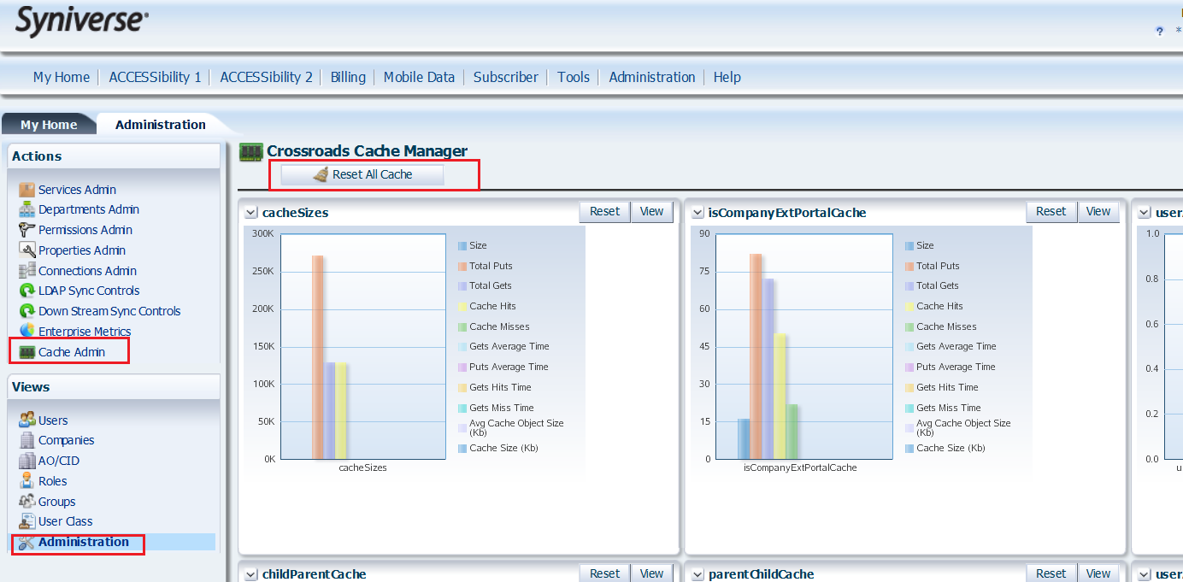

## Backout Procedure

To completely backout this release, perform the following:

* Execute **./**Data_Security.backout from the cgi-bin directory
* Execute ./runSqlRunner.sh Data_Security.backout.sql
* Execute **./**A2P.backout from the cgi-bin directory
* Execute ./runSqlRunner.sh A2P.backout.sql
* Execute ./grantPermissions ICSMS_Metcalf_INC87743Grant-Backout PORTAL from the cgi-bin directory
* Execute **./**ICSMS_Metcalf_INC87743.backout from the cgi-bin directory
* Execute ./runSqlRunner.sh ICSMS_Metcalf_INC87743.backout.sql
* Rename datasecurity.sp to datasecurity.sp.bak (or remove datasecurity.sp) and restart the proxy servers
* Restart the Crossroads Web Servers on each App Tier Server

## Monitoring/Verification Procedures

#### Data Security

Please verify the below company and user permissions are available on the Crossroads gui.

* Company Permissions

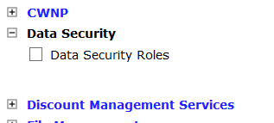

* User Permissions

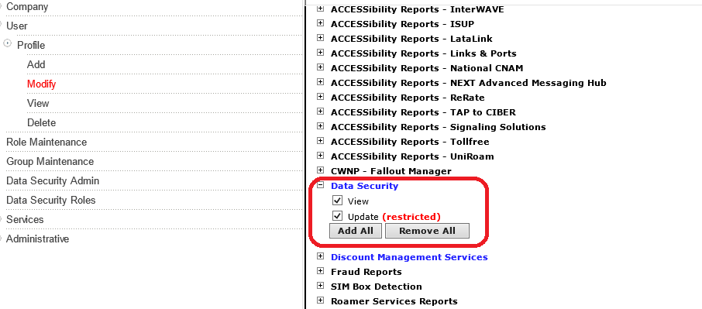

These user perms are Syniverse Admin only perms with NO company permission, which will drive

“Data Security Admin” menu.

* Menu links

**Check the menu links under Admin tab:**

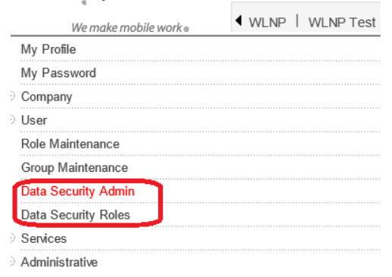

This company permission [Data_Security_Roles_Co] & User Class drives the “Data Security Roles” menu.

End User of a company that has the Data security roles company permission shouldn’t be seeing the “Data Security Roles” menu.

**User Class           Name                                                 Proposed Access**

0                            End User                                            No Access

#### A2P

**Company Permissions:**

Please verify the below company and user permissions are available on the Crossroads gui. The user permissions are 1 to 1 associated with the company permissions as evident from the name of the permissions which are same for the company and users.

### For Non Syniverse Company

* **Company Permissions:**

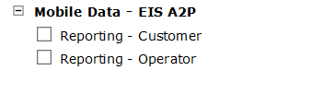

* **User Permissions:**

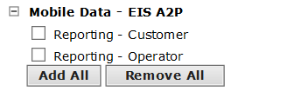

### For Syniverse Company

This permission should be available and assigned to the Syniverse Company by default.

* **Company Permissions:**

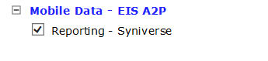

Syniverse user should have this permission available for them to be assigned.

* **User Permissions:**

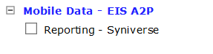

**Menu item:**

Make sure if any of the above user permissions is assigned to the user then this menu link should be available:

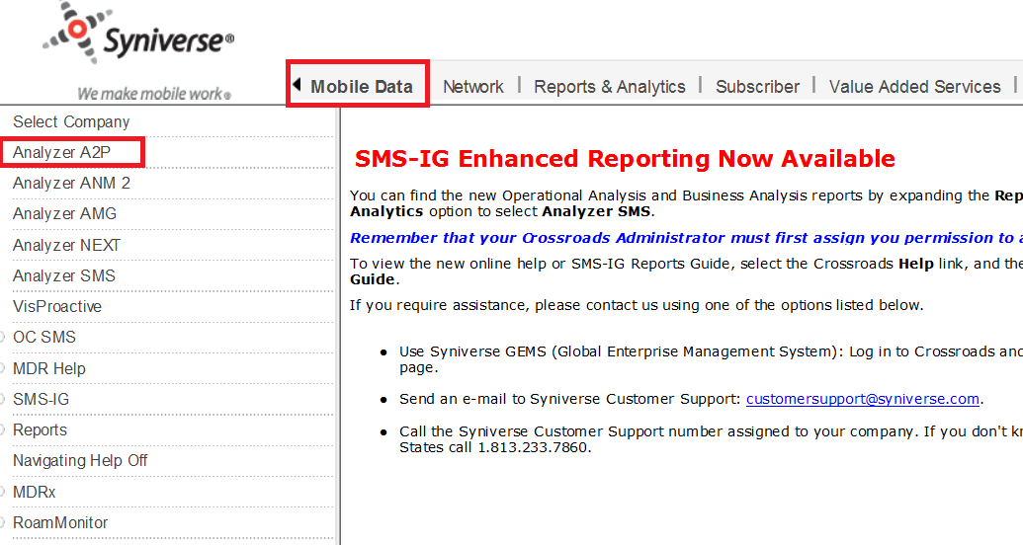

#### ICSMS Metcalf INC87743

**User Permissions:**

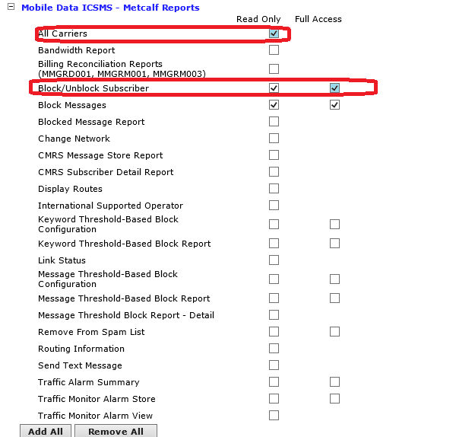

Check for “Full Access” to the existing permission “Block/Unblock Subscriber”.

New Permission called ‘All Carriers’ added for Syniverse users.

# Test Procedures

Centralized Testing has created a system test plan and executed it in the System Test environment. Please see their documentation and completion report for more information.